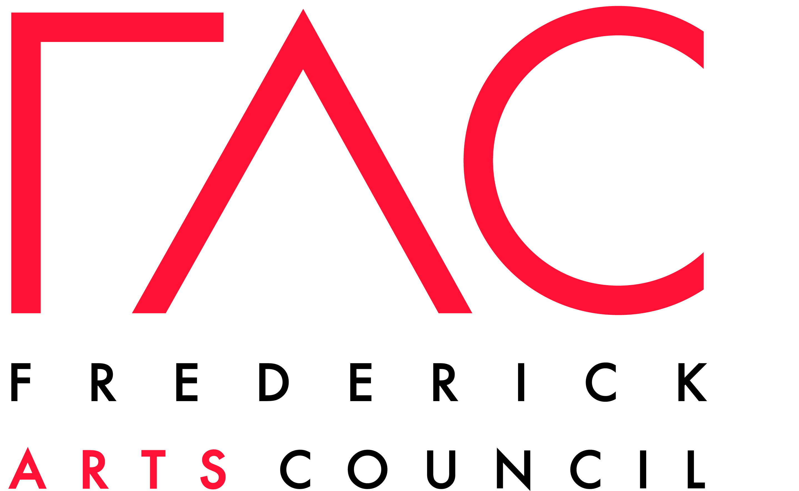

Application Guidelines for Funding

For Visual Arts Instruction

The Michael Campagnoli Visual Arts Scholarship
And the Brittany Nicole Shiben Memorial Scholarship

The Michael Campagnoli Visual Arts Scholarship established by the Frederick Arts Council and the Campagnoli family.
The Brittany Nicole Shiben Memorial Scholarship established by Brittany’s loving family and friends.

Scholarship monies are available for students K – 12, who are pursuing visual arts instruction in a group or individualized setting. The scholarships offered and their respective criteria are as follows:

Applications are being sought from students 5-17 years of age in Frederick County who are in need of financial assistance to pursue their training in visual arts.

- Applications will be considered for primary and secondary school students who have demonstrated talent, commitment, and aspiration in visual arts instruction.

- Applications must request funding for visual arts instruction only.

How to Apply

- Applicants need to submit one application packet to be eligible for scholarships from both funds.

Application packets should consist of two letters, one from the applicant or the applicant’s legal guardians and one from the applicant’s instructor. Each letter should be hand-written or typed on one 8 1/2” x 11” sheet of paper, as follows:

A. The first letter should be from the applicant stating the reasons that the applicant deserves the scholarship, the applicant’s commitment to pursuing visual arts instruction or visual arts activities requiring participation fees, or other related expenses, any obstacles that the applicant has had to overcome to pursue this instruction or visual arts activity, the financial resources available to pay for instruction, the fees associated with instruction, and the applicant’s personal goals. The applicant’s name, age, school, level of schooling, as well as the legal guardian’s contact information including their address, telephone number, e-mail address, and both the applicant and the legal guardian signatures.

B. The second letter should be from the applicant’s instructor that will using the scholarship monies stating the applicant’s level of talent, progress in achieving higher levels of skill development, the fees associated with instruction, and track record of approaching instruction with diligence and commitment. The instructor’s name, address, telephone number, and e-mail address and signature must be included.

C. The application should include 2-5 photographs of the applicant’s original artwork. The artwork may be completed in any medium(s) and may be of any subject matter.

Application should be at least THREE PAGES total.

- Completed applications must be delivered via post, email, or hand to info@frederickartscouncil.org (with the subject line “Visual Arts Scholarship”) or to FAC Offices:11 West Patrick Street, 2nd Floor, Frederick, MD 21701

- Applicants will be notified of the outcome of their application within 30 days.

- Scholarship checks will be written directly to the instructor or visual arts center on a reimbursement basis.

- Scholarship monies should be used by June 30, 2022 or they will be forfeited.

- Scholarship recipients must permit their names and photos to be used in publicity and press releases pertaining to The Michael Campagnoli Visual Arts Scholarship and The Brittany Nicole Shiben Memorial Scholarship.

- Scholarships are not automatically renewable. Scholars may re-apply.

- Please address all questions to Info@FrederickArtsCouncil.org—Please put “Visual Arts Scholarship” in the subject line.

