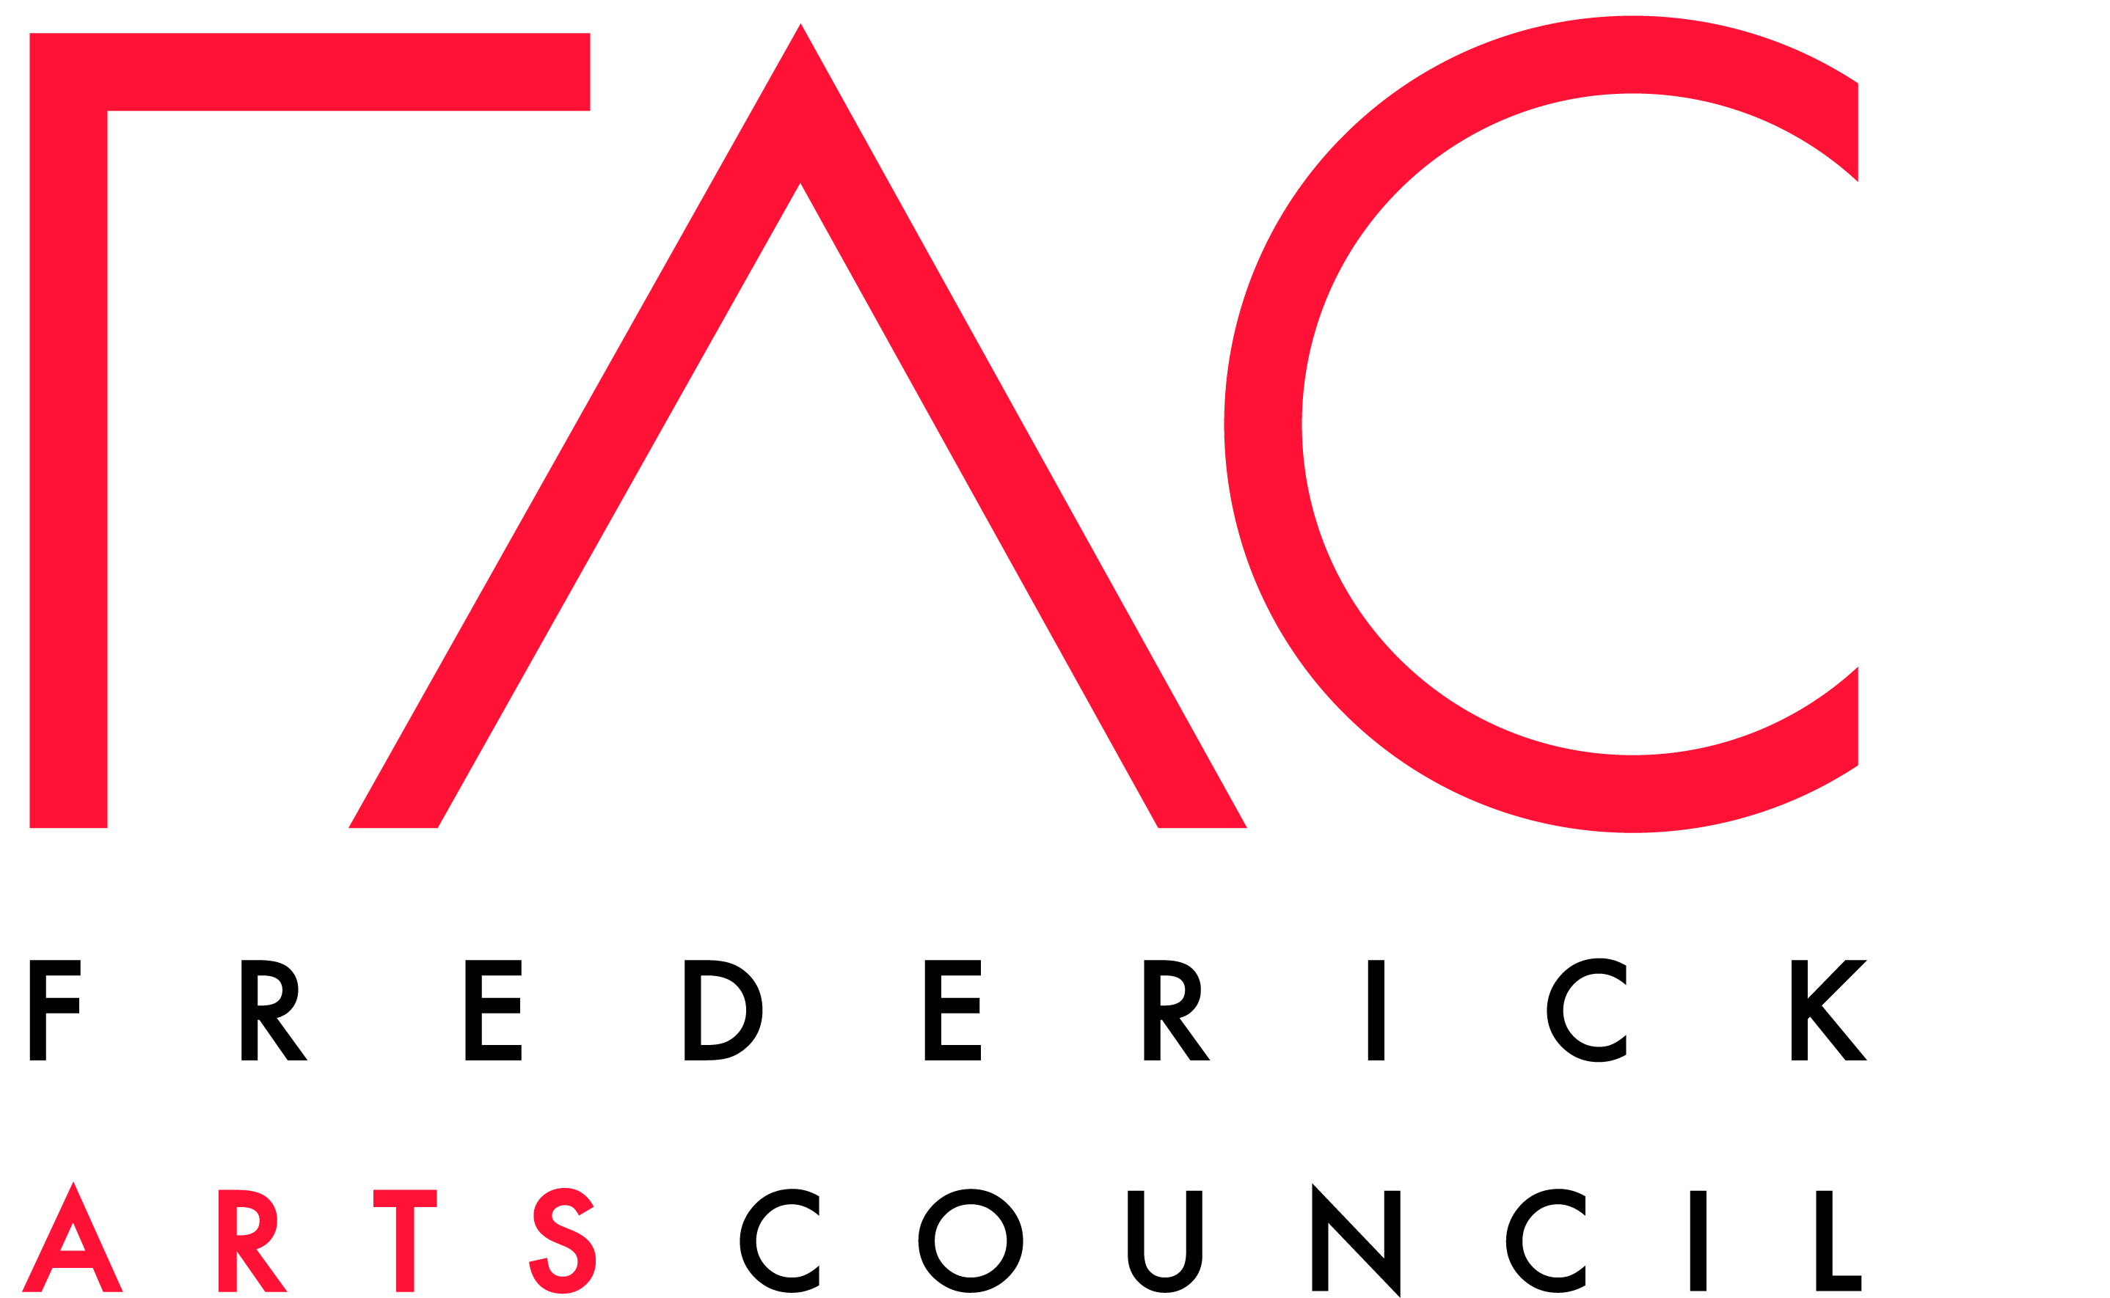

Application Guidelines for Funding

For Vocal or Instrumental Music Instruction

Thelma Gross Music Scholarship

Scholarship monies are available for students ages 5 to 17, who are pursuing vocal or instrumental instruction in a group or individualized setting. The scholarship offered and the respective criteria are as follows:

Applications are being sought from Frederick County Public School students attending kindergarten through 11th grade, who are in need of financial assistance to pursue training in vocal or instrumental performance.

- Applications will be considered from elementary, middle and high school students who have demonstrated talent and commitment to pursuing private music instruction.

- Applications must request funding for private instruction, only.

How to Apply

- Applicants need to submit one application packet to be eligible for scholarships from both funds.

Application packets should consist of two letters, one from the applicant or the applicant’s legal guardians and one from the applicant’s instructor. Each letter should be hand-written or typed on one 8 1/2” x 11” sheet of paper, as follows:

A. The first letter should be from the applicant or the applicant’s legal guardians stating the reasons that the applicant deserves the scholarship, the applicant’s commitment to pursuing private music instruction or musical activities requiring participation fees, costume fees, or other related expenses, any obstacles that the applicant has had to overcome to pursue this instruction or musical activity, the financial resources available to pay for instruction, the fees associated with instruction, and the applicant’s personal goals. The applicant’s name, age, school, grade, the legal guardian’s name, address, telephone number, e-mail address, and signatures from both the applicant and the legal guardian must be included.

B. The second letter should be from the applicant’s instructor that will using the scholarship monies stating the applicant’s level of talent, progress in achieving higher levels of skill development, the fees associated with instruction, and track record of approaching instruction with diligence and commitment. The instructor’s name, address, telephone number, and e-mail address and signature must be included.

Do not include videotapes, audiotapes, or any other supplemental materials. The application should be TWO PAGES total.

- Completed applications must be delivered via post, email, or hand (not post-marked) by March 14, 2022 at 5pm to info@frederickartscouncil.org (with the subject line “Music Scholarship”) or to FAC Offices: 11 West Patrick Street, Frederick, MD 21701 (drop in the mail slot). You will receive a confirmation that your submission has been received.

- Applicants will be notified of the outcome of their applications by April 1, 2022.

- Scholarship checks will be written directly to the instructor or musical group on a reimbursement basis.

- Scholarship monies should be used by April 1, 2023 or they will be forfeited.

- Scholarship recipients must permit their names and photos to be used in publicity and press releases pertaining to The Thelma Gross Music Scholarship Fund .

- Scholarships are not automatically renewable. Scholars may re-apply.

- Please address all questions to Info@FrederickArtsCouncil.org with “Music Scholarship” in the subject line.

