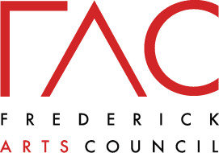

Intersections
by Mike Shaffer

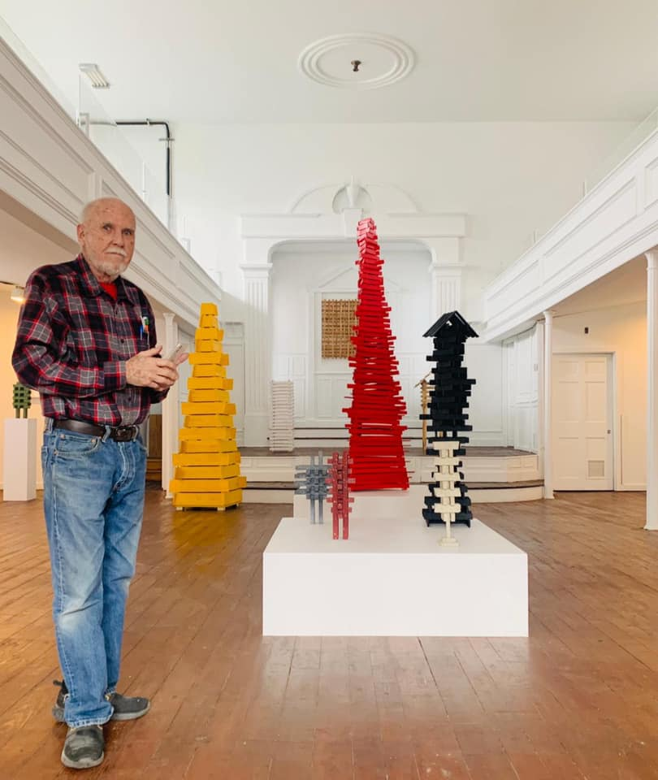

Intersections was on display at Frederick Arts Council’s Art Center at 5 East 2nd Street from February to April 2021. The exhibition features larger-than-life towers which have formed a large part of Mike Shaffer’s work as a sculptor.

Shaffer creates diverse works of art that capture his desire as an artist to make things that are “uniquely entertaining, thought-provoking, important, and relevant.” Shaffer is past-president of the Washington Sculptors Group.
“Mike Shaffer is an accomplished artist with a striking perspective,” said Louise Kennelly, Executive Director of the Frederick Arts Council. “We are delighted to feature him as a member of Frederick’s arts community and provide greater exposure to his work. This show is a retrospective of a long and active career.”
Shaffer is a multi-disciplinary artist who works out of his studio in Ijamsville. He has exhibited in over 200 formal group exhibitions, including at the American University Museum at the Katzen Art Center, in his long career in addition to twenty-four solo exhibitions and received over a dozen awards and honors for his artistic accomplishments.

Artist Statement:
The show is called Intersections because it presents a variety of shapes or forms that illustrate the myriad places and ways intersections exist in the world today. I see my artwork as being fragments of a greater wholeness.

Press:
The Frederick News-Post: https://www.fredericknewspost.com/news/lifestyle/seniors/mike-shaffer-presents-intersections-at-frederick-art-council/article_0080db8b-d79d-5bba-8da3-a4aab311aaaf.html

Website: https://www.mikeshaffer.net/ Twitter: @shaffermike

