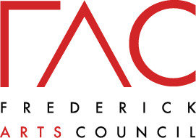

Autumn
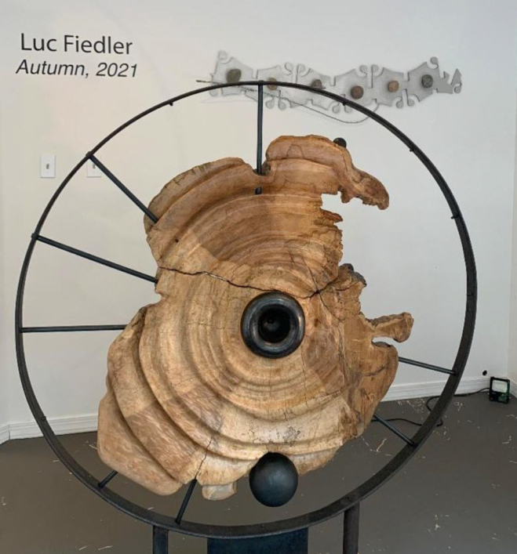
by Luc Fiedler

Autumn by Luc Fiedler was an exhibition of sculpture and dimensional artwork. It was on display at Frederick Arts Council’s 11 West Patrick Street Gallery in the Fall of 2021.
Luc is an award-winning sculptor with an M.F.A. from the University of California in Sculpture and Intaglio Printmaking with additional studies in Art and Architecture in Belgium, England, France, and Italy through the Intur Kultur Off-Campus Program. Luc has an extensive background in metal fabrication and bronze casting. His sculptures are collected widely both privately and publicly and are in galleries across the country.
Recent awards include “Best in Show” at VRMC’s National Juried Exhibit, First Place at the 26th Annual North American Exhibit of Miniatures, and Honorable Mention at the 84th Annual International Exhibition of Fine Art in Miniature. Luc works out of his studio and foundry in Unionville, Maryland and he is a member of the TAG Gallery.
Artist Website: www.elfstudios.biz

