Lisa Dillin

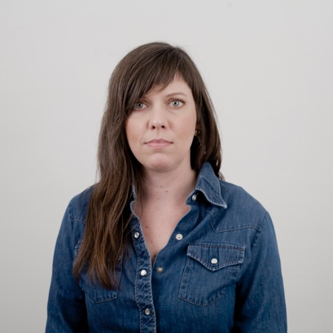

Lisa Dillin is an interdisciplinary Baltimore-based artist working primarily in sculpture and participatory art practices. Dillin earned her BFA in photography from Atlanta College of Art in 1998 and her MFA in sculpture from Cranbrook Academy of Art in 2006. Her work has been selected for exhibition at various venues including the Baltimore Museum of Art and The Contemporary Museum in Baltimore, MD, Hamiltonian Gallery and Washington Project for the Arts, in Washington, D.C., Vox Populi and Practice Gallery in Philadelphia, PA, as well as Nurture Art and Transmitter in Brooklyn, NY. Art fairs include the Select Art Fair in NYC, Aqua Art Fair and Artist-Run Art Fair in Miami, FL. Honors include 2014 and 2017 MSAC Individual Artist awards in sculpture, second place prize winner of the Trawick Awards in 2014, and selection as a Sondheim Prize Finalist in 2012.

Artist Statement:
Since March of 2020 the physical and emotional space between each of us has widened like a deep chasm along an active fault line. Our isolation is a necessity in order to protect one another – but, this shared experience has left a lasting impression on us. As the last year passed by, small and midsize businesses closed, many permanently. Once buzzing city centers - many of which were already underutilized and in decline - have gone silent. City buildings and suburban retail centers that had long ago fallen into disrepair eerily await our return, while new sites join the process of decline as nature begins to lay claim to them.

As we travel to our old familiar places, ducking our heads into doorways that have not been used in some time, we find that vestiges of what was abound. We have left traces of ourselves in every nook and cranny of our towns and cities. These human remnants are not dissimilar to messages in a bottle: they are clues to what came before, a voice waiting to be discovered if the recipient is open to receiving. Markings left by those who stood in the space you are standing in now are mysteries waiting to be solved. Who was here? What were they like? Where are they now? Time is all that separates us from one another in such spaces of investigation. When lost in thought in an empty reverberating room, we daydream nostalgically of lively vibrant gatherings full of smiling faces – so close yet so far away from us now.

Sorry we missed you is an attempt to make tangible the emotional quality of the sustained isolation and economic decline that characterizes this time. Sorry we missed you extends an open hand to the viewer and whispers “I understand how you feel, I’m feeling that way too. I miss you. I miss people. I miss people like you. I’m worried about our futures just as you are. I am right alongside you, feeling the vacancy of this moment and waiting for the day when we are together again - rebuilding.”

Watch the artist talk:
https://drive.google.com/file/d/1TE_AbFghvuaGXKo4FnpN2R2LOARKg4zY/view?usp=drive_web
Digital Catalogue: https://www.lisadillin.com/news

Press:
The Frederick News-Post: https://www.fredericknewspost.com/news/arts_and_entertainment/sorry-we-missed-you-sound-and-sculpture-exhibit-at-fac-art-center/article_a9b8dbc6-58d4-516c-bd57-66fc2c97ac77.html

BmoreArt: https://bmoreart.com/2021/08/tarnished-coins-chewed-gum-vacant-sales-racks-lisa-dillins-sorry-we-missed-you.html
Cranbrook Academy of Art: https://cranbrookart.edu/2021/08/05/the-frederick-arts-council-art-center-opens-solo-exhibition-of-baltimore-artist-lisa-dillin/

Website: lisadillin.com Instagram: @lisadillin

