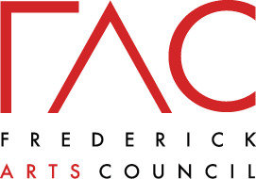

Golden Mile – In Focus
by Wing Young Huie and local photographers

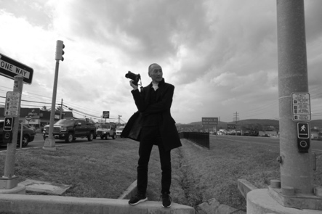

‘Golden Mile – In Focus’ is a Frederick Arts Council public art installation designed by Wing Young Huie featuring photographs of – and by – Frederick residents. Young Huie conducted interactive workshops at schools, cultural centers, ESL classes, and other locations throughout the Golden Mile of Frederick, MD. The project uses images of people from these workshops and are displayed on the sides of buildings and in windows as way to highlight, celebrate, and connect our diverse cultures and communities. The project was unveiled in July 2020 and is still on display. See a map of the locations.
Photographers included in this project are Wing Young Huie, Lluvia Baten Lopez, Janae Metellus, Jillian MacMaster, Lisa McLeod-Simmons, Jordan Miller, Jinn Phaka, Patricia Stockman, Dedipya Unadkat, Joshua Warui, Ira Wexler, Contributing Advisor.
Wing Young Huie Biography:
Young Huie is a photographic artist who has been photographing diverse and cross-cultural communities for many years. He is known for innovative photography projects which actively engage the community portrayed. He has received national and international recognition for his work and was the recipient of the McKnight award.

Press:
The Frederick News-Post
Frederick Magazine
CODAworx

