Trying to make Aurica without breaking Pangea
by Christian Benefiel

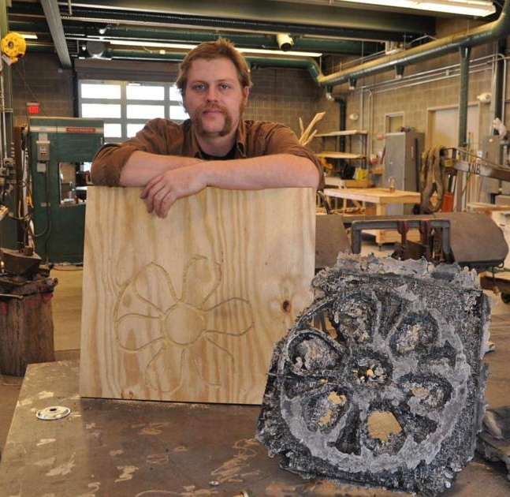

Trying to make Aurica without breaking Pangea was on display at Frederick Arts Council’s 11 West Patrick Street art gallery from January to June 2021. The installation by artist Christian Benefiel focuses on interconnected construction of elements that rely on each other for strength, structure, and support.

Christian Benefiel is a Sculptor who works in material, installation and extended objects. His work addresses systems and relationships as they relate to inter-connectivity, and causality. He has shown nationally and internationally and is in collections and public installations throughout the United States.

Artist Statement:

Causality describes the relationship between direct and indirect factors of desired effect. The way in which materials, people and elements interact, react and depend on one another is the string that ties my work together. I am interested in the action that separates hope from optimism, in materializing expression and effort.

Many of my works are formed from interconnected construction of elements that rely on each other for strength, structure and support. The shape and systems reflect on personal elements, domestic relationships, cultural norms, as well as what I perceive of hidden systems of universal forces larger than me or us-weather, commerce, the restrictions of physics etc. I am particularly interested with this work in the fragility in social structure which is often assumed to be solid by design. This work serves as a self-describing metaphor, where I am both a system and an interconnected element contained within encapsulating and increasingly larger units and networks that make up my reality.

In the reality there is an undeniable influence of fortune, luck and/or ignorance that is held against probability, permanence and consequence. The temporary nature of the work and in individual’s time with it, correlates to the persistence and imperfection of memory and recalled interpretation. The pieces are in state of collapse; they have a defined lifespan, and each subsequent installation is an interpretation or variation of the previous structure.

The works touch on themes consumer culture, occupation of space and resource, and individual perception of value. While subtle and surface, the distillation of these concepts is ultimately a way of understanding the way that I am part of a larger whole, and how my decisions and action affect that system.

Artist Website: www.christianbenefiel.com

Artist Social Media: instagram.com/blackscrewstudios

