Barn Art Initiative
by Lynda Andrews-Barry, Becky Borlan, Elliott Hamilton, Julie Maynard, Matt Mercer, Alexander Rudd, Samantha Sethi and Virginia Warwick

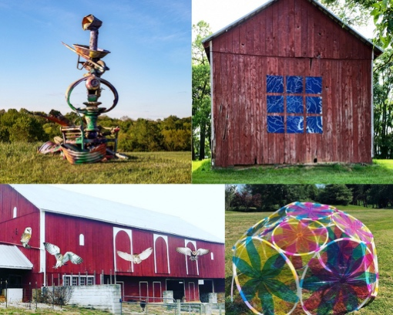

The Barn Art Initiative is a public art exhibition that includes eight works commissioned by The Frederick Arts Council and are displayed on properties throughout Frederick County. The works are installations which reflect the subtle beauty of the environment. All works were inspired by nature or made use of natural materials. The project was unveiled in June 2021 and is still on display. See a map of the locations.
A selection of artworks relating to the installations were on display at the FAC Art Center during the summer of 2021.

The Barn Art Initiative features work of Maryland artists including Lynda Andrews-Barry, Becky Borlan, Elliott Hamilton, Julie Maynard, Matt Mercer, Alexander Rudd, Samantha Sethi and Virginia Warwick.

Participating Frederick County locations include Hidden Hills Farm and Vineyard, Vorac Suffolks, Lilypons, South Mountain Creamery, Sheridan’s Way and Arnoldstown Barn.

Locations and Artists:

- Hidden Hills Farm and Vineyard, 7550 Green Valley Rd Frederick MD
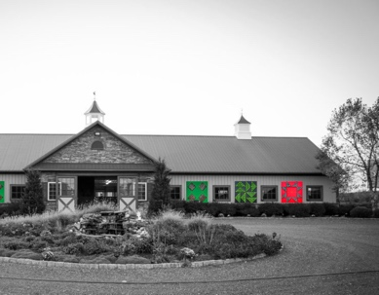
Artist: Lynda Andrews-Barry
Artist statement: Lynda Andrews-Barry is a multidisciplinary artist with a practice encompassing time-base meda, installations, and sculptures created from found and fabricated objects that reflect the often unseen and ignored beauty of our world.
Artist website: https://lyndaandrews-barry.com/

- Lilypons, 6800 Lily Pons Road, Adamstown, MD
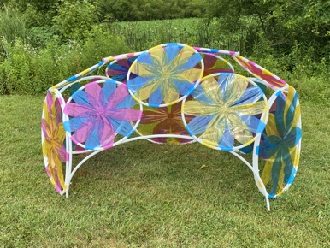
Artist: Becky Borlan
Artist statement: By exploring fundamental building block shapes, I aim to interrupt the ubiquity of the built environment with whimsical and playful sculptures that express my constant wonderment with the visual world. Contrasting color and hard-edge geometry with both organic and man-made settings throws the landscapes we come to ignore into a more stark relief. This leads the viewer to noticing, appreciating, and engaging. The conversation between site and sculpture is essential and my process involves in depth

exploration of specific site conditions, which are then distilled and abstracted into bold colorful gestures that the viewer can relate to on a human scale. My sculptures emphasize that play is a serious pursuit, one that should be revisited often to refresh our perception and challenge our mindsets.
Artist website: http://www.beckyborlan.com/

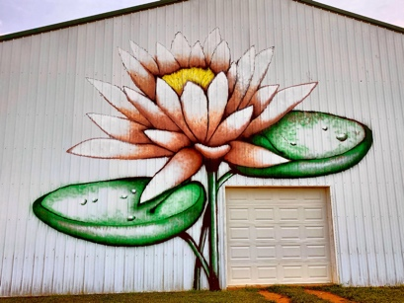
Artist: Matt Mercer
Artist statement: For me as an artist I make to create art that's entertaining. A way for the viewer to escape into my abstract Expressionism world and enjoy the colors and textures and shapes. I've been developing this style for about 6 years now and I really want to continue this style and have an exhibit to go along with this kind of abstract Expressionism I've been doing. Picasso is my favorite artist and the Cubism. A base a lot of my deconstructed faces abstract expressionism paintings on his cubism work. And street art and graffiti has a big influence on my art and paintings. I'd like to continue this style on a larger scale as well 4' by 4' paintings and 6' by 6' paintings! I like painting big I love painting murals in large scale! Thank you
Artist website: http://matt-mercer.pixels.com/

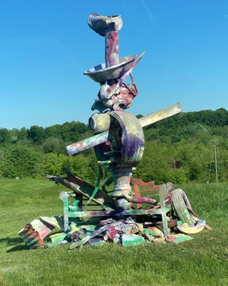
Artist: Alexander Rudd

Artist statement: The driving force of my work is a deep respect for nature. Someone with a similar paradigm may find my visual language readily or directly, while others may find irony or a serious humor. Steering myself and my work away from futility while also approaching the enormous scale of our environmental crisis is my highest goal. I am developing a practice of shaping space that encourages an accountable slowing of mass consumption and provokes self-realization of the absurd, unsustainable, and undeniable status of all ecosystems. Furthering this paradoxical goal, I hope to achieve this awareness by layering the spiritual pursuit of playfulness, grace, release, and of course love. The idea that we can remain positive in the face of humanity's most critical challenge ironically mirrors my hope that art can truly function inside this reality. I idolize the legacy of land artists, and in turn envy the efficiency of mainstream ideas. This vicious dichotomy shall grow a stage in which to communicate about and through what truly connects us all, Mother Earth. Baltimore’s Rinehart School of Sculpture is my new home base, and I intend to engage the local complexity as a petri dish in which to grow this artistic message.

- Vorac Suffolks, 5814 Broad Run Road Jefferson MD
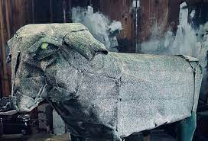
Artist: Virginia Warwick
Artist statement: Concentrated within a three-dimensional realm, Virginia Warwick’s practice juxtaposes playfulness, humor and earnest themes of nature. Virginia explores the ways that either art objects or bodies as performance take up space. The materials and mediums that Virginia uses are central to the meaning behind her work. Many of the materials are found, transformed and, or unrecognizable from their original form into something a new. This demonstrates her feelings about nature and animals and how the materials she uses, which are familiar to humans are in fact detrimental to the environment. Growing up surrounded by a variety of animals and the natural world, Virginia feels animals and nature are an intrinsic part of her identity and weaves them into her world.

This fascination and awe becomes part of the three dimensionality and exploration that Virginia pursues in performance and practice.
Artist website: https://www.virginiawarwick.com/

- Arnoldstown Barn, 1304 Arnoldstown, MD
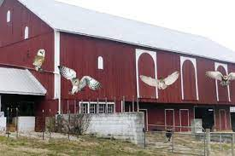
Artist: Julie Maynard
Artist statement: My work is a form of painting with paper on two- or three-dimensional surfaces, often incorporating objects picked up along the Potomac River and city streets. It reflects on the impact our culture has on the environment and the impact that nature still has on us. My goal with an exhibition is to surround the viewer with visuals and with sound. I like to hang some pieces overhead, or high on a wall, to tug at visitors' peripheral vision. I often include a video to provide a soundtrack: passing freights for Train Wrecks, for instance, or cooing doves for Mass Produced Pigeons. I often start with one of my photographs (or a historic picture in the case of Train Wrecks), then re-create it with scraps of paper from magazines and gift catalogues or fast-food wrappers. At the first, I try for realism, mimicking colors and values, but after a while I go for broke and strange things creep in. Along the way text often accumulates, and I'm happy to let some of it stand. The title of a piece can always be found somewhere in the image as a piece of found text.
Artist website: www.juliemaynard.com

- South Mountain Creamery, 8305 Bolivar Road, Middletown, MD
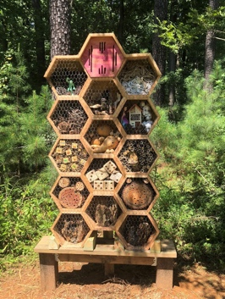
Artist: Elliott Hamilton
Artist biography: Elliott Hamilton is a Maryland based environmental sculpture and painter and who is best known for his playful insect house environmental sculptures and colorful landscapes. Elliott’s sculpture and paintings have been shown in juried exhibits at the Prince Georges Delegate Building in Annapolis, at the Brentwood Arts Exchange in Hyattsville, Montpelier Arts Center in Maryland, Harmony Hall Art Center in Fort Washington, Anthenaeum Gallery in Alexandria, VA, Southern Aquatics Center Gallery in Brandywine, MD, and at the Robinson Nature Center in Howard County.
Artist website: https://www.eehamilton.com/

- Sheridan’s Way, 15050 Sixes Rd Emmitsburg MD
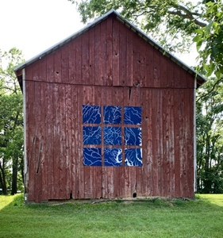
Artist: Samantha Sethi
Artist statement: Samantha Sethi’s interdisciplinary practice embraces a blend of physical and digital objects exploring the way the world we see and move through can be modeled both visually and experientially. Through natural materials and processes, such as ice, sunlight, and sediment, Sethi creates works which are simultaneously actions and images, both the event at hand and the drawing or trace used to represent it through time. These works find their source in the artist's view of our world as a landscape both inhabited and studied by humankind, altered even as it is observed -- understanding the world as both the location and the material of our pursuit of meaning.
Artist website: http://www.samanthasethi.com/

