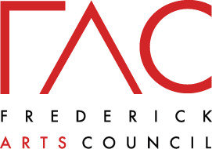

A Community Story

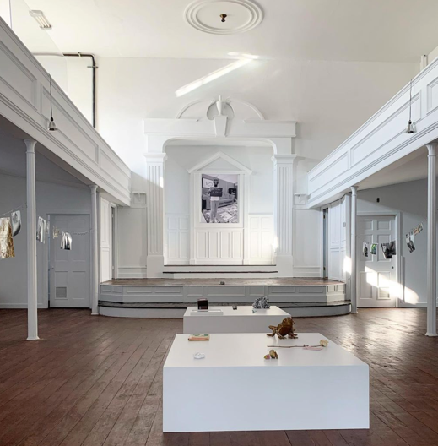

A Community Story was the first exhibition on display at Frederick Arts Council’s Frederick Arts Center at 5 E 2nd St. The exhibition ran from September – November 2020.
A Community Story from 'Golden Mile in Focus' by Wing Young Huie which is open on the Golden Mile.
Members of our community were invited to bring a photograph of family or someone significant to them and a small object which is representative of their culture. The exhibit was a way to share our stories and showcase the people of Frederick and the meaningful objects which relate to their respective cultures.

Press:
WDVM25: https://www.localdvm.com/news/maryland/frederick-arts-council-opens-new-art-center/
Downtown Frederick Partnership: https://downtownfrederick.org/event-pro/frederick-arts-council-center-opens/

